An RFID Tag-Based Device for Lecture Assessment based on a Quiz to ensure Confidentiality and
 | Integrity
¹Dheeraj Pandey  Dept. of Computer Science  KIET Group of Institutions  Ghaziabad, India  dheeraj.pandey@kiet.edu | ²Saksham  Dept. of Computer Science  KIET Group of Institutions  Ghaziabad, India saksham.2226cs1015@kiet.edu | ³Pallavi Sharma  Dept. of Computer Science  KIET Group of Institutions  Ghaziabad, India pallavi.2226cs1116@kiet.edu

Abstract—Classroom assessments based on traditional MCQ methods usually come down to utilizing smartphones or internet-based systems. These systems tend to distract the students and at the same time limit the teacher's ability to accurately assess the learning outcomes. All these drawbacks make it harder for educators to comprehend the effectiveness of the lecture and pinpoint the areas in need of improvement. Hence, we put forward a completely new design for a hardware device utilizing the low-cost RFID/NFC that would be of great assistance to the teachers operating under Outcome Based Education (OBE) framework. Students indicate their preferences by four NFC tags portraying A, B, C, and D options for MCQs, while an RFID reader collects all the inputs and stores them directly into a local database without any need whatsoever for internet connection. After the teacher inputs the correct answers, the system automatically evaluates the responses and provides the educator with insights to help assess the level of understanding among students, improve the teaching methods, and consequently increase the overall quality of lectures. This is in stark contrast to the traditional use of NFC, which has been limited to mere automation; instead, this device presents a unique, safe, and non-distracting solution for classroom assessment. It places teachers in the position of being able to rely on real-time and always accurate outcome-based evaluation data.

Keywords—Outcome Based Education, RFID, NFC, Lecture Effectiveness, Classroom Assessment, Non-Internet Device, MCQ Evaluation, Teaching Efficiency

INTRODUCTION
Currently, there are many challenges associated with the current assessment approaches in the modern classroom due to the rising use of smartphones that have the ability to connect to the internet. These students appear to be distracted, exhibit irregular student responses, as well as the associated risk of malpractice, thus affecting the assessment results for multiple choice questions. Additionally, the issue of internet connectivity poses a challenging possibility that may not be stable, hence influencing the availability of the devices and consequently the assessment results for multiple choice questions for the Outcome Based Education approach.
To overcome the drawbacks, there is a need to implement assessment tools under controlled conditions with no distractions, preferably those which function independently of the mobile devices and the internet. The proposed system using RFID/NFC technology satisfies the need as it allows the structure of the MCQ assessment to be done in an organized way. Students will utilize four different NFC tags marked as options A, B, C, and D of the questions, and the responses will be stored using the RFID reader since it will enable the collection of all the responses without using the internet or the mobile devices.
The strategy has a number of important benefits. It ensures active participation irrespective of the availability of devices, it removes distractions in the classroom, and the prospect of malpractice using technology is reduced. The recording of immediate responses improves the accuracy and efficiency of the assessment process, and the fact that it goes offline removes the issue of the need for an internet connection. The solution ensures better teaching modification and promotes the culture of OBE.

LITERATURE REVIEW
The incorporation of interactive quiz resources in academia has been a key foundation for contemporary approaches in instruction for enhanced engagement, comprehension, and performance among learners. The technology enables instant evaluation and immediate feedback, thereby allowing teachers to make dynamic modifications in instruction methods. The current comparative study will examine the advantages and efficacy of different resources on quiz tools based on reviews in research papers.
Some tools that are now prominent in the educational setting include various features for a range of educational requirements. These tools are:
- Kahoot! Founded on the principle of gamification, Kahoot! is another useful tool for the classroom as it enables the preparation of quizzes, surveys, or discussions [1] [2] [3].
- Quizizz: This tool, which focuses on self-paced learning and allows students to complete tests independently, may be particularly valuable for the purposes of formative assessment [1] [4].
- Mentimeter: This is quite an intriguing tool as it is more focused on developing presentations that involve real-time interactions through quizzes, polls, or surveys by encouraging feedback [5] [6].
- Socrative: This tool also has multiple functions to be used in various forms of questions, including multiple-choice questions, and therefore allows both formative and summative tests [7] [8] [9].
- ClassPoint: Offering enhanced features through forms of slide-specific quizzes and AI-based questioning, adding to the interactivity of the lecture [5].
The detailed summary of the same has been described in Table I.
Table I: Comparison of the various Online assessment tools

Tools | Key Features | Strengths | Weaknesses
Kahoot! | Gamified quizzes, leaderboards, real-time feedback | High engagement, motivates students | Limited question types, may not suit all subjects
Quizizz | Self-paced quizzes, detailed analytics | Supports individualized learning, flexible | Less engaging compared to Kahoot!
Mentimeter | Interactive presentations, polls, surveys | Real-time feedback, enhances engagement | Limited advanced features
Socrative | Multiple question types, detailed reporting | Versatile, suitable for formative assessments | Less engaging, lacks gamification
ClassPoint | AI-generated quizzes, slide-specific assessments | Dynamic, adaptive learning experiences | Steeper learning curve for instructors

In the study by different researchers, the various aspects of the study have been pointed out. The details of the same are as follows:
2.1 Student Perceptions and Engagement
2.1.1 Student Preferences
Evidence has shown that the choice of quiz tools among students is often influenced by either the learning or assessment environment. For example, students in a medical learning environment preferred using Socrative due to its simplicity and effectiveness in formative assessments [8]. Also, students in an academic environment preferred using Mentimeter due to its engaging nature of learning [6]. On the contrary, students have preferred to use tools that provide them with an anonymised environment, such as Mentimeter, to avoid the pressure of being in an assessment environment [6].
2.1.2 Impact on Engagement
The role of quiz software in engaging students is a very important topic. The following are key factor in their effectiveness. Kahoot! and Quizizz have been proven to enhance user engagement via gamification such as Mentimeter that offers interactive features [1] [4]. With its features such feedback and interactive presentations, has also been found to to optimize engagement of students in both online and offline environments.
Nevertheless, the efficiency of these applications may depend upon on the context. For example, whereas Kahoot! could be very While highly effective in large competitive environments, it could possibly have less effect when it comes to situations involving such as small group settings and collaborative projects where anonymity is desired. preferred [1][2].
2.2. Impact on Learning Outcomes
2.2.1 Enhanced Learning Through Interactivity
Interactive quiz software has been shown to improve learning results through the encouragement of active participation and real-time feedback. Tools such as Mentimeter and Socrative make it possible for teachers to quickly assess their understanding and to enable them to adjust their methods of teaching dynamically [7] [5] [6].
2.2.2 Role of Gamification
Gamification, seen in such platforms as Kahoot!, Quizizz, and Classcraft, integrates an important role in increasing student motivation and engagement. Research shows that gamified quizzes may result in: to better academic achievement, especially when administered as formative assessments,[1] [4] [3]
2.3 Limitations and Challenges
Even with the advantages they offer, quiz assistants have flaws. Technical problems, such as connectivity problems and platforms It should also be noted that a lack of compatibility between the users and the dependence on technology could result in distractions, especially in settings that have students. In addition, they tend to be prone to multitasking [11]. platform compatibility and connectivity problems, which would necessarily deal with for the successful use of quiz applications [10] [9]. Moreover, issues of morality, like privacy & security issues, especially when using data-gathering tools for students [10].

PROPOSED METHODOLOGY
Based on the literature survey, it has been identified that the major gap in this field is the limitations of connectivity that hampers the smooth conduction of the quiz in the lectures, as if the connectivity is not available in the classroom or goes in between, the complete purpose of the same is defeated and the interest of the student for such activities is also hampered. To overcome the need to use the internet, a technological modification has been suggested to achieve the targets, but in a little different way. As we know that the RFID tags are available in the markets, which are static in nature but could provide the information stored in them. This information is updated by the RFID writer; hence, to do so in our logic, the RFID tag's working has been exploited. The RFID ID tag has a small chip on the tag, which is powered by the antenna that powers this chip. Now, to enable the chip, the power is provided in the form of radio frequency, which is captured by an antenna. Now, in our approach, the antenna is connected to the switch and chip, as the electricity will always flow through the shortest path the enabling the switch will disable the chip. Now, to get the response of the students, four such tags are connected to the switch and are shared among the students. The record of each tag is stored in the RFID writer machine, which can easily identify which option has been pressed by the student. Hence, the response for the same is recorded. The graphical representation of the circuit is shown in Fig. 1.
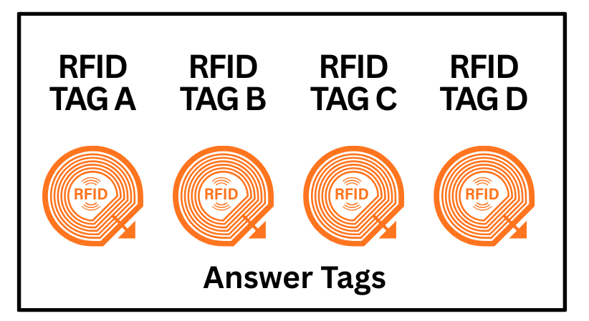
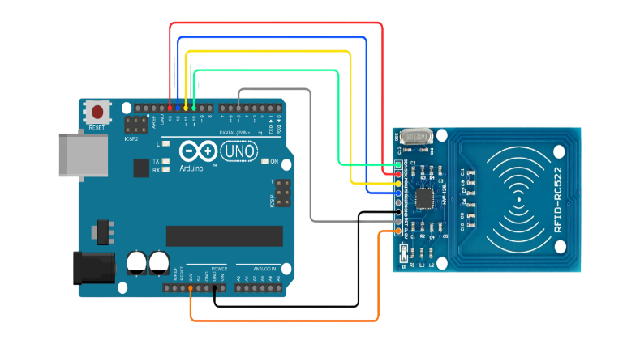

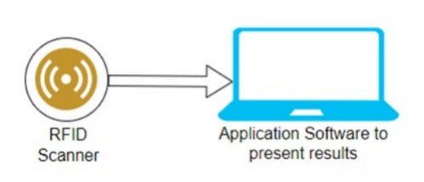
Fig. 1: Describes the complete Hardware Representation

The proposed device described in the Fig 1 is simple and could perform the task taking the assessment without internet, and does not require expensive devices like mobiles, tablets, or desktops and could perform the task in a simple chalk and board environment. The teacher could ask the question by any means, and students have to switch accordingly. Once all the students have completed opting for the answers, the RFID reader attached to the system of the teacher could help in identifying the correct choice from the different students.

RESULTS AND DISCUSSION
The device developed is simple, robust and cheaper. This device will behave as a one-time investment, as there is no need to get the subscription; only the number of devices has to be procured. As the device is very simple and could be designed at a very low cost, this device could have penetration not only in the institutions that have good infrastructure, but also in the schools where there may be a scarcity of funds to start with the smart classroom. Another major challenge that was discussed in various literature was the breach of privacy, as it was easier to log in on devices like mobiles that also contain huge amounts of personal information, which would be known to the outside world. As the student also resists getting identified for providing the wrong answer, but in this tool, as devices could be randomly distributed, there is no possibility for the candidate to be identified, hence it will instil confidence in the gradual learner to participate in the competitions and score.

Fig. 2: Comparison of the two models

In the study of power consumption, it has been assumed that the mobile device has been operating for 1 minute of time during which the display, network and browser have been operating. The total consumption for the same has been 0.67 watts per device. Similarly, the source of power consumption for the proposed hardware is when the RFID tags are read. This also assumes that reading a single device tag will require 0.037 Watts; therefore, the comparison for the 10 to 60 devices has been presented in Fig. 2.
Another point of comparison of the two technologies, assuming all the infrastructure for the conduct of the approach is to be borne by the institution. The comparison for the costing has been presented in Fig. 3.

Fig. 3: Compares the Cost of implementing the same in class

CONCLUSION
As the device proposed is overcoming all the challenges that exist in the previous approaches, like high cost of implementation, privacy issues, and limited connectivity, it is a strong candidate for classroom assessments. The device cost is around 50 INR per head and can be reduced with mass production. The major drawback is handling multiple and more interactive questions, which can be addressed in future improvements.

REFERENCES
- A. Amalia, M. A. Daynuari, and B. Setiaji, “Analysis of Differences in the Use of Kahoot and Quizizz Applications in Improving Analytical Thinking of Physics Education Students, Universitas Negeri Yogyakarta,” Mar. 2024.
- A. Rajak and Vidushi, "Analysis and Actions Planned for Programme Outcomes in Outcome Based Education for a Particular Course," 2024.
- A. I. Wang, M. Zhu, and R. Sætre, “The Effect of Digitising and Gamifying Quizzing in Classrooms,” Jan. 2016.
- Z. Zainuddin, M. Shujahat, H. Haruna, and S. K. W. Chu, “The role of gamified e-quizzes on student learning and engagement,” Feb. 2020.
- S. Antonenko and M. K. Izmailova, “Comparison of interactive student engagement services: Mentimeter and ClassPoint,” Dec. 2023.
- E. Armstrong, L. Rogers, M. Lyon, and J. L. Selway, “Mentimeter Improves Student Engagement in Online Clinical Anatomy Revision Sessions: A Programme Evaluation,” Nov. 2024.
- I. Fonseca, N. C. Martins, and F. Lopes, “Exploring Interactive Tools for Education and Online Assessment: A Comparative Analysis,” Nov. 2024.
- V. Ingalls, “Students Vote: A Comparative Study of Student Perceptions of Web-Based Student Response Systems,” Sep. 2020.
- I. V. Bellmunt et al., “Un estudio comparativo entre dos herramientas de respuesta de audiencia en las aulas universitarias”, Mar. 2019.
- J. Barrio-Barrio, “Interactivity software tools for teaching in ophthalmology,” Mar. 2023.
- S. K. Mand, S. J. Cico, M. R. C. Haas, N. E. Schnabel, and B. H. Schnapp, “Let’s get active: Technology-enhanced audience interaction to promote active learning,” May 2024.

